EE380 Project #4 Solution Fall 2017

Question 1)
We say x is a normal or Gaussian random variable with parameter and if its density function is given by:
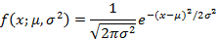
and its distribution function is given by:
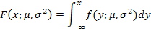
We can express in term of the error function (erf) as follows:
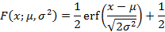
The probability density function (pdf) and cumulative distribution function (cdf) of normal distribution can be calculated using two built-in functions normpdf and normcdf in matlab.
- Write two Matlab function on your own based on above equations, one for calculating normal pdf and one for calculating normal cdf. (treating as inputs of the functions)
- With x=[-6, 6], plot the pdf and cdf for the following pairs of : (0, 1), (0,, (0, , (-3, 1), (-3, ), (-3, . (Please plot them in two figures: one contains all the pdf curves, and one contains all the cdf curves)
- What can you observe about the affect of on normal pdf and cdf curves?
-----------------------------------------------------------------------------

function fx = NormalPdf(x,Mu,SigmaSq)
% Returns the Pdf of Normal(Mu, SigmaSq), at x,
% where Mu=mean and SigmaSq = Variance
%
% Usage: fx = NormalPdf(x,Mu,SigmaSq)
if SigmaSq <= 0
error('Variance must be > 0')
return
end
Den = ((x-Mu).^2)/(2*SigmaSq);
Fac = sqrt(2*pi)*sqrt(SigmaSq);
fx = (1/Fac)*exp(-Den);

-----------------------------------------------------------------------------

-----------------------------------------------------------------------------

function Fx = NormalCdf(x,Mu,SigmaSq)
% Returns the Cdf of Normal(Mu, SigmaSq), at x,
% where Mu=mean and SigmaSq = Variance using
% MATLAB's error function erf
%
% Usage: Fx = NormalCdf(x,Mu,SigmaSq)
if SigmaSq <= 0
error('Variance must be > 0')
return
end
Arg2Erf = (x-Mu)/sqrt(SigmaSq*2);
Fx = 0.5*erf(Arg2Erf)+0.5;

-----------------------------------------------------------------------------

-----------------------------------------------------------------------------

% PlotPdfCdfNormal.m script file
% Plot of some pdf's and cdf's of the Normal(mu,SigmaSq) RV X
x=[-6:0.0001:6]; % points from the subset [-5,5] of the support of X
subplot(1,2,1) % first plot of a 1 by 2 array of plots
plot(x,NormalPdf(x,0,1),'r') % pdf of RV Z ~ Normal(0,1)
hold % to superimpose plots
plot(x,NormalPdf(x,0,1/10),'b') % pdf of RV X ~ Normal(0,1/10)
plot(x,NormalPdf(x,0,1/100),'m') % pdf of RV X ~ Normal(0,1/100)
plot(x,NormalPdf(x,-3,1),'r--') % pdf of RV Z ~ Normal(-3,1)
plot(x,NormalPdf(x,-3,1/10),'b--') % pdf of RV X ~ Normal(-3,1/10)
plot(x,NormalPdf(x,-3,1/100),'m--') % pdf of RV X ~ Normal(-3,1/100)
xlabel('x')
ylabel('f(x; \mu, \sigma^2)')
legend('f(x;0,1)','f(x;0,10^{-1})','f(x;0,10^{-2})','f(x;-3,1)','f(x;-3,10^{-1})','f(x;-3,10^{-2})')
subplot(1,2,2) % second plot of a 1 by 2 array of plots
plot(x,NormalCdf(x,0,1),'r') % DF of RV Z ~ Normal(0,1)
hold % to superimpose plots
plot(x,NormalCdf(x,0,1/10),'b') % DF of RV X ~ Normal(0,1/10)
plot(x,NormalCdf(x,0,1/100),'m') % DF of RV X ~ Normal(0,1/100)
plot(x,NormalCdf(x,-3,1),'r--') % DF of RV Z ~ Normal(-3,1)
plot(x,NormalCdf(x,-3,1/10),'b--') % DF of RV X ~ Normal(-3,1/10)
plot(x,NormalCdf(x,-3,1/100),'m--') % DF of RV X ~ Normal(-3,1/100)
xlabel('x')
ylabel('F(x; \mu, \sigma^2)')
legend('F(x;0,1)','F(x;0,10^{-1})','F(x;0,10^{-2})','F(x;-3,1)','F(x;-3,10^{-1})','F(x;-3,10^{-2})')

-----------------------------------------------------------------------------

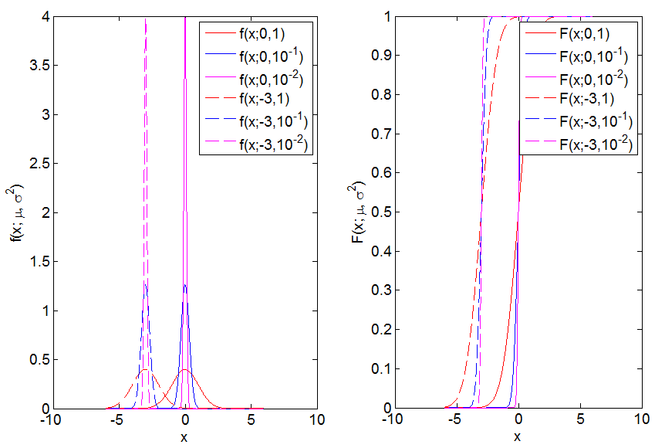

Question 2)
Consider books with thicknesses, W, normally distributed between 1 and 3 cm. These books are piled in stacks of N=1, 2, 3, 4, 5, 10 or 15 books. Plot the simulated height distribution (use hist function with number of bins equal 10) for each stack of N books; and compare with a Gaussian distribution with a mean of (µ_{w}=(1+3)/2) and a standard deviation of
(σ_{w}=sqrt((3-1)^2/12). (Mean and standard deviation only used for Gaussian plot, this plot is used for comparison.) You just need to show plots for N= 1, 2 and 10.
-----------------------------------------------------------------------------
%Project 4:
%Question 2:Plotting the simulated height distribution for each stack of N books and compare with a Gaussian.

clear all
close all
Experiments=1e3;
limits=[1 3]; % Limits of uniform distribution
Books=[1 2 5 10 15]; % Number of books for the experiments
nbins=10;
%
N=Experiments;
a=limits(1); b=limits(2);
mu_w=(a+b)/2; sig_w=sqrt((b-a)^2/12);
X=zeros(N,1);
%
for B=Books
mu=B*mu_w;
sig=B^0.5*sig_w;
for k=1:N
x=(b-a)*rand(B,1)+a;
w=sum(x);
X(k)=w;
end
%
% Graphs ------------------------------------
[h, xbar]=hist(X,nbins); del=diff(xbar(1:2));
pdf=h/N/del; % pdf is the density function
figure; bar(xbar,pdf); grid;
hold;
z=min(X):0.1:max(X);
gf=1/(sig*sqrt(2*pi))*exp(-(z-mu).^2/(2*sig^2));
plot(z,gf, 'r', 'LineWidth',3)
title(['Distribution of stack height; N=', num2str(B),' books'])
hold;
%
end

……………………………………………………………………………………………………………………………………………………………………..
To prepare the 5 graphs: set B=1, 2, 5, 10, and 15 to make the plots separately. In these calculations, no ‘end’ required.

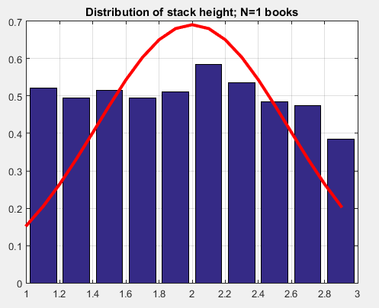
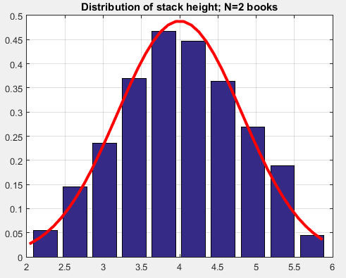
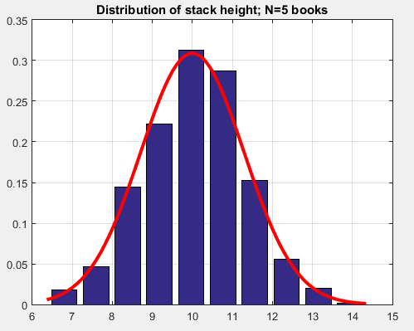
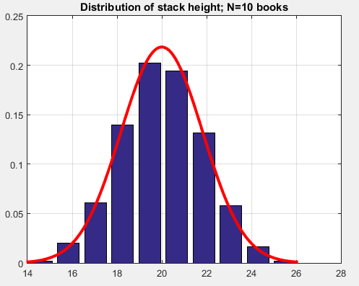
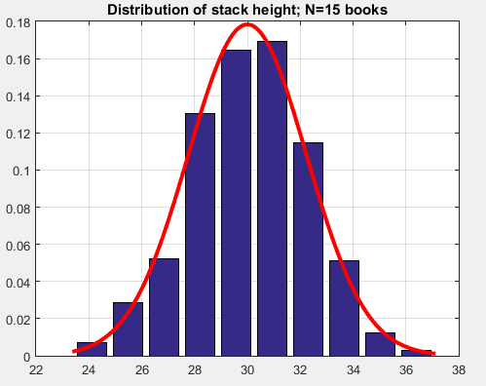

Question 3)
To build up central limit theorem by following steps:
Step 1, to generate a uniform distribution x(I) between 0 and 1, and plot it
Step 2, by randomly adding any two x(I) to have 2nd distribution and plot it,
Step 3, repeat the step 2 for two more times (total 3 times)and plot the last distribution.
Step 4, Use normal distribution to fit the above 3 plots.
(a)
n=10000;
x=0;
x=rand(1,n);
mu=mean(x);
sigma=std(x);
bin=10;
[h,qs]=hist(x,bin);
h1=h/max(h);
figure;
bar(qs,h1);
hold;
z=min(x):0.01:max(x);
Gg= normpdf(z, mu, sigma)
Gg1=Gg/max(Gg);
plot(z, Gg1, 'r', 'LineWidth', 3)
title([‘(a) Uniform Distribution of Random Process’])
hold;

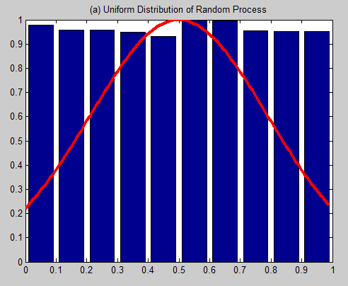
(b)
n=10000;
x=0;
y=0;
x=rand(1,n);
for i=1:n
y(i)=(x(i)+x(randi(n)))/2;
end
for i=1:n
x(i)=y(i);
end
mu=mean(x);
sigma=std(x);
bin=10;
[h,qs]=hist(x,bin);
h1=h/max(h);
figure;
bar(qs,h1);
hold;
gf= inline('(1/(sigma*sqrt(2*pi)))*exp(-(z-mu).^2/(2*sigma^2))');
z=min(x):0.1:max(x);
Gg= normpdf(z, mu, sigma)
Gg1=Gg/max(Gg);
plot(z, Gg1, 'r', 'LineWidth', 3)
title([‘(b) 1-modification of Uniform Distribution of Random Process’])
hold;
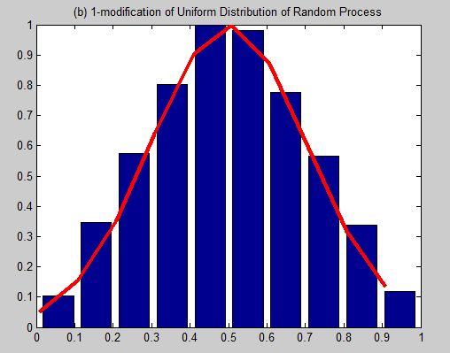

(c)
n=10000;
x=0;
y=0;
m=0;
for m=1:4
x=rand(1,n);
for i=1:n
y(i)=(x(i)+x(randi(n)))/2;
end
for i=1:n
x(i)=y(i);
end
end
mu=mean(x);
sigma=std(x);
bin=10;
[h,qs]=hist(x,bin);
h1=h/max(h);
figure;
bar(qs,h1);
hold;
gf= inline('(1/(sigma*sqrt(2*pi)))*exp(-(z-mu).^2/(2*sigma^2))');
z=min(x):0.1:max(x);
Gg= normpdf(z, mu, sigma)
Gg1=Gg/max(Gg);
plot(z, Gg1, 'r', 'LineWidth', 3)
title([‘(c) 4 times modification of Uniform Distribution of Random Process’])
grid on
